Java Develop Guide
1. Copy reader java files
Copy the "com" folder from ".\SDK\JAVA\x32" or ".\SDK\JAVA\x64" to the associated java project directory, as shown in Figure 1.1.
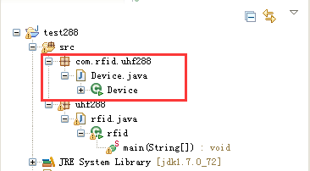
Figure 1.1

2. Copy dynamic link library corresponding JNI files
Copy "UHFReader288.dll" and " com_rfid_uhf288_device.dll " from ".\SDK\JAVA\x32" or ".\SDK\JAVA\x64" to the associated java project directory (or C:\WINDOWS\system32), as shown in Figure 1.2.
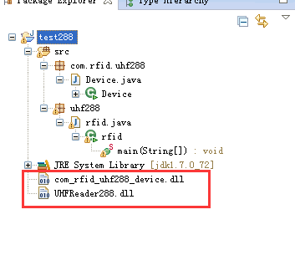
Figure 1.2

3. API calling
Perform the following steps in the relative project files.
1) Declaration.
import com.rfid.uhf288.Device.*;
2) Load dynamic link library.
System.loadLibrary("com_rfid_uhf288_Device");
3) Create an object.
com.rfid.uhf288.Device reader = new com.rfid.uhf288.Device ();
After completing these step, user can now call various functions stated in the library, as shown in Figure 1.3.
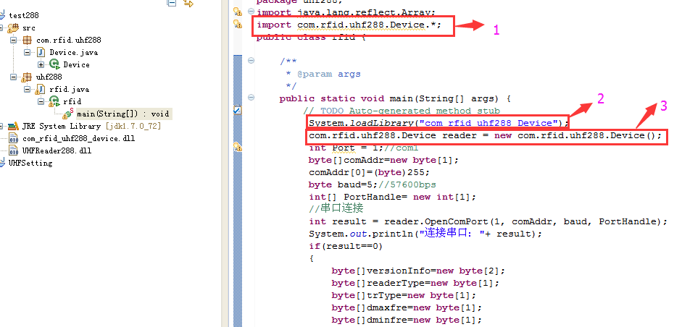
Figure 1.3
For more detail, refer to the provide source code in ". \demo\java\testdemo ".

